ARCHITECTURE 3
The Cause and Effect of Changes in Surabaya’s Architecture

A. Madeline , Vinny, Michael Z. and Maverick

WISMILAK
1928 – 1962
Special Police Office
We don’t have information about the changes to the police office because, due to the war, there is no documentation about this.

1962 – 1976
Cigarette Factory
- Change: It was changed into a cigarette factory.
- Cause: The company needed a place to produce cigarettes.
- Effect: The company produces cigarettes.

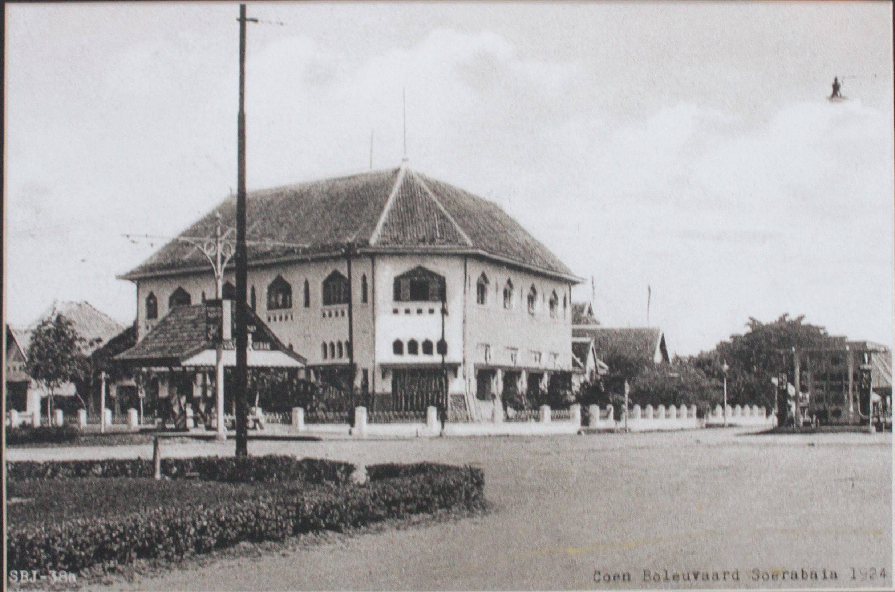

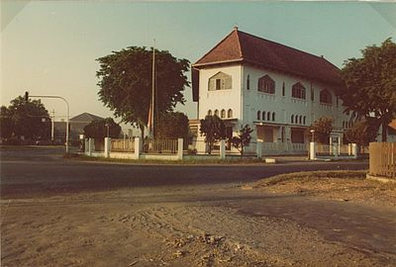

1976 – Now
Office
- Change: This building was changed from a cigarette factory into the office of Wismilak.
- Causes: The cigarette company was very successful so the factory needed bigger area. This building was changed into an office and the factory moved to bigger premises.
- Effect: So the company would have larger space for producing the cigarette and this building was used as an office.

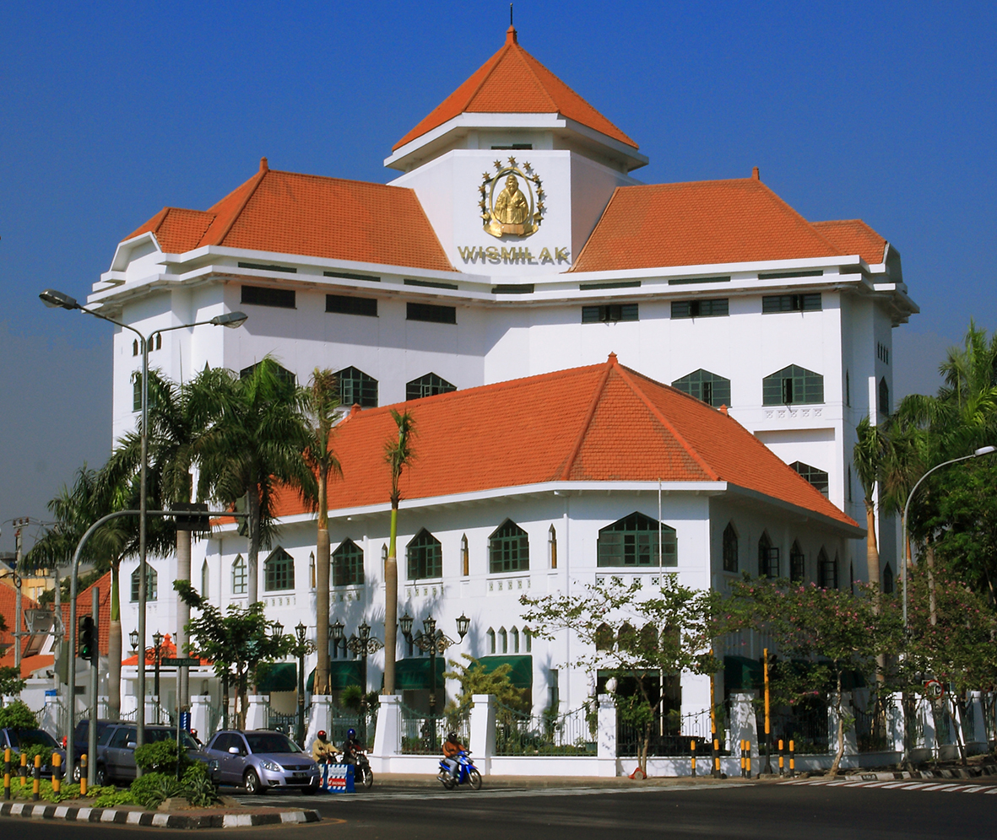

HOUSE OF SAMPOERNA
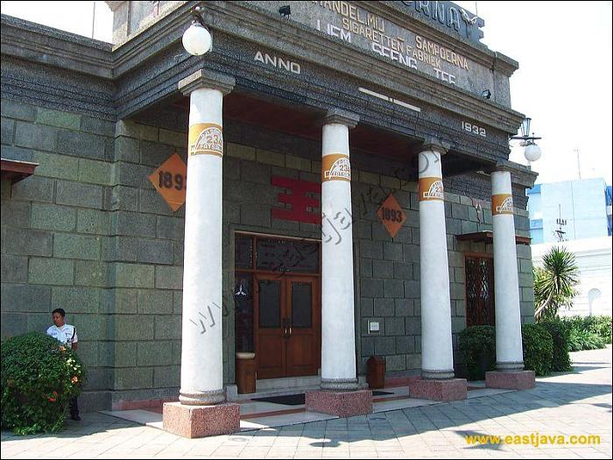
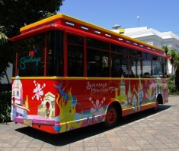
Bibliograophy
2003 – Now
Museum , Art Gallery, Shop and Café
- Changes : House of Sampoerna is now open for public. Everyone can visit the building for free. The area in the first floor, which can be accessed by the main door, is a museum. A shop is located in the second floor and there are windows there to view the workers making the cigarettes. The symbol of Sampoerna has been added to the walls, floor and windows.
- Causes : The company has a history of success in cigarette production and needed a place to show their history. Sampoerna is also aware of the importance of preserving Surabaya’s history and culture.
- Effect : Visitors to the building can discover the history behind this successful company. People can also buy clothes, books and others in the shop and they can also see the workers making cigarettes on a small scale. The company even provides a free bus to visit a few of Surabaya’s historical places.
1932 – 2003
Cigarette Factory
- Changes: The building was changed into a cigarette factory, except for the central assembly building. Then a theater was built in the central assembly building.
- Causes: The founder of Sampoerna, Seeng Tee, decided to use the building not just for cigarette company, but also as a place for his family to live. Seeng Tee also decided to build a theater in the central building for an assembly place.
- Effect: Seeng Tee had more space for producing cigarettes and for his family to live. Also, the theater is a good place for entertainment.

1858 – 1932
Orphanage managed by the Dutch
We don’t have any information about the changes to this building because there is no documentation mentioning the orphanage.

Websites
- Anonymous. “Sampoerna’s founder story.” [Online] Available http://houseofsampoerna.com/e_sampoernaco_founder.htm, 8 February, 2013
- Anonymous. “House of Sampoerna.” [Online] Available http://www.eastjava.com/tourism/surabaya/house-of-sampoerna.html, 8 February 2013

Additional
- Mr. Dukut’s booklet (given at assembly)

