EXHIBITION
WHERE WE ARE IN PLACE & TIME
PYP 6 2012 – 2013

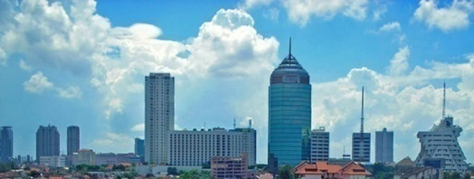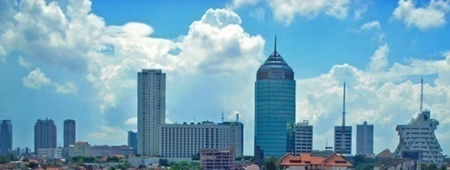

Students : Madeline, MICHAEL, VINNY & ERICK

2nd Assessment
the cause and effect of changes in Surabaya’s OLD architecture

Students create a web organizer (flow chart) to show the information gathered on Surabaya’s old architecture from past until now.

Formative Criteria
- Gather reliable and valid information from various resources
- Identify the factors or reasons which cause Surabaya’s architecture to change
- Explain how changes to Surabaya’s architecture is based on its era and function
- Explain the effects of the changes on the architecture and to society
- Think creatively on using mind map

Assessor : Mr. Ary

