√EXHIBITION
WHERE WE ARE IN PLACE & TIME
PYP 6 2012 – 2013

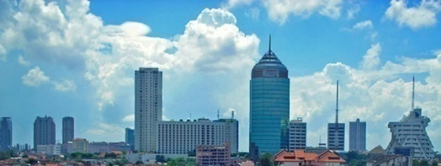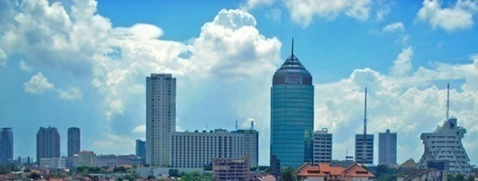

Students : Madeline, MICHAEL, VINNY & ERICK

1st Assessment
KINDS OF SURABAYA ARCHITECTURE

In a group students will create a visual presentation using Microsoft PowerPoint consisting of information about Hotel Majapahit, House of Sampoerna and Cheng Ho Mosque.

Formative Criteria
- Define architecture
- List the kinds of architecture in Surabaya based on its function
- Explain the influences of other countries on Surabaya architecture
- Organize an excursion to some historical places in Surabaya
- Cooperate collaboratively in all group work

Assessor : Ms. Mirna

